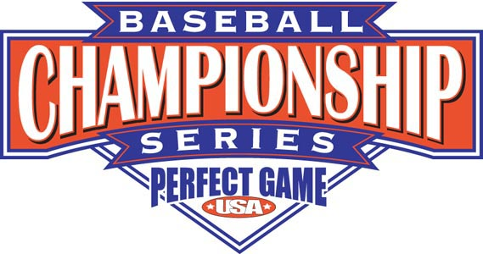

18U BCS Finals Tournament Format

- 40 Teams – 10 pools of 4
- Teams will play 3 pool games the first 2 days
- Teams will be reseeded into new pools of 4 after day 2. Each new pool will consist of a 1st place team, 2nd place team, 3rd place team, and 4th place team out of the original pools. Teams will play 3 more pool games in the next 2 days
- Playoffs will have 16 teams starting on Day 5 (July 19)
- Playoffs consist of seeds 1-16 (Winners of the reseeded pools and 6 wildcards. Wildcards will be a team who does not win a reseeded pool with the best overall record of all 6 pool games. All playoff teams are seeded based on all 6 pool games and the tiebreaker system in rules) No teams from the same organization will be matched up in the 1st round of the playoffs. If this happens we will move the lower seed down.
- Teams must use BBCOR -3 bats that are legal according to the National High School Federation. NO WOOD BATS ALLOWED
- Teams are required to check the website after Day 2 to know their schedule for the next 2 days
- Mandatory manager’s meeting will be held at 5 PM at City of Palms Stadium on July 14th.
- Rawlings Home Run Challenge and Fastest Man Contest will take place on July 14th at 6:00 PM at City of Palms Stadium. Each team is allowed one player in the Home Run Challenge and 2 in the Fastest Man Contest. Every team needs to email their entrants to benford@perfectgame.org before the July 7th.
- Water coolers will be supplied in every dugout at every field. NO COOLERS will be allowed into the fields.
- All on-field coaches only must check in at the gate to receive your tournament wristband.

